STEELCASE

**Website :** <https://www.steelcase.com>

**Note : Please add your feedback in red colour. Thank you**

**#01 - FSOTO Mobile Caddy | DSMC**

* **Using the model name as the search term**

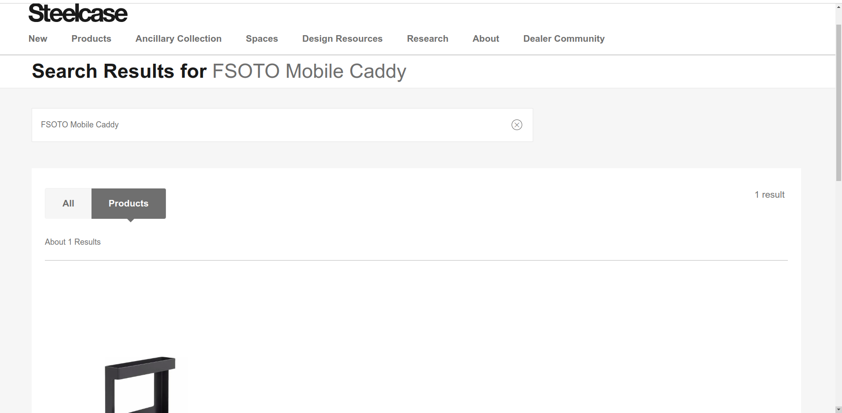

**Result:**

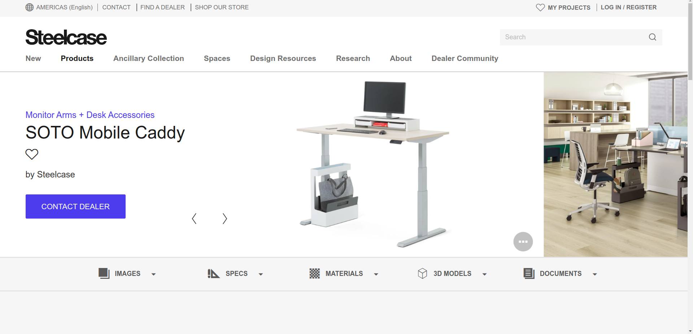

* **Using the mfr number as search term**

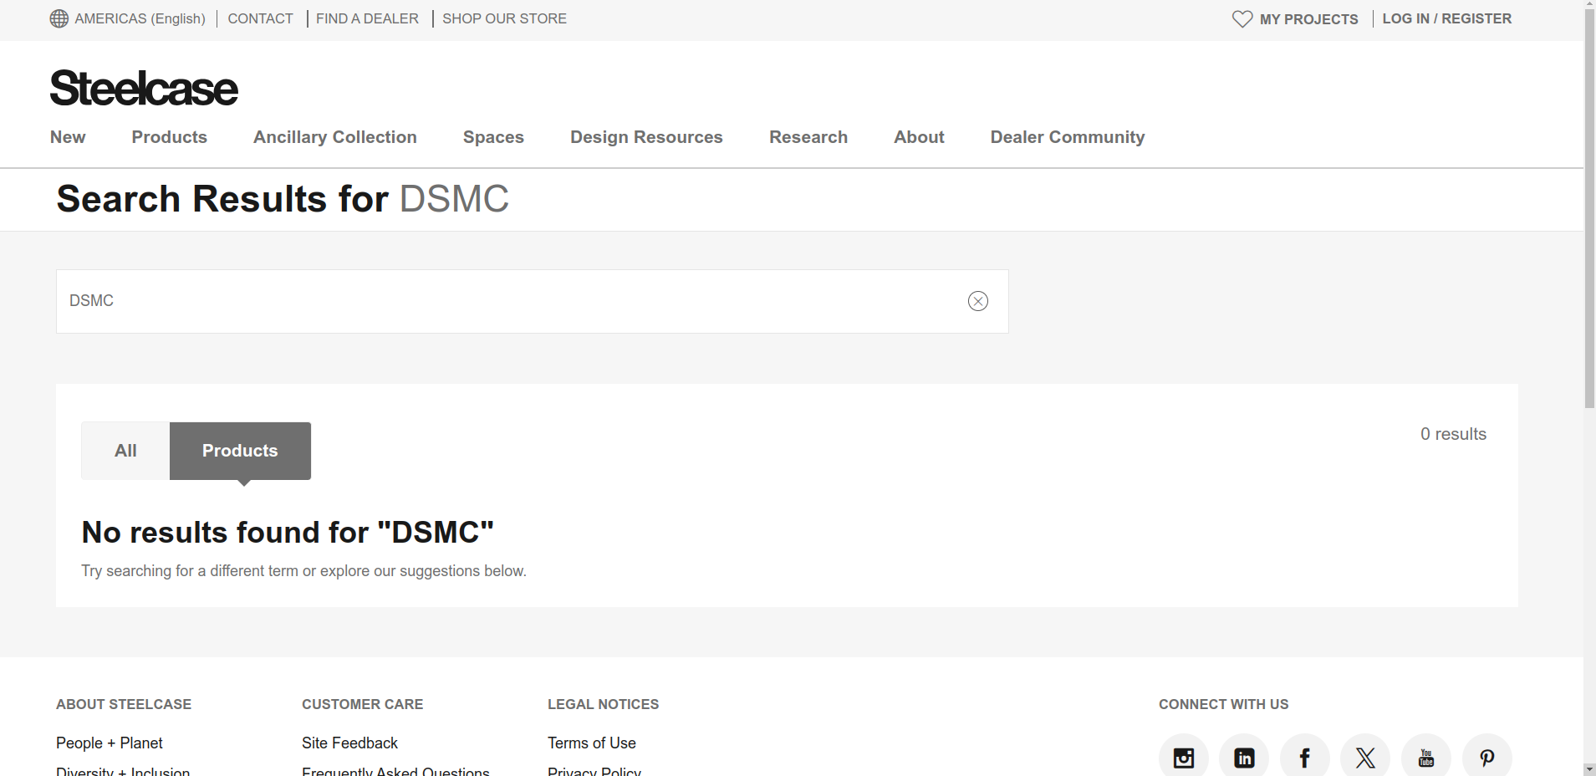

**Similar result products:**

* **Model name | mfr number**
* **Aspekt Bench | SC4043**
* **Bassline One Seat Bench | TSBLNS1**
* **PolyVision a3 CeramicSteel Flow 47''W x 95''H | FLOW**
* **Relay CPU Holder Standard (White) | HTCU2**
* **Relay HTW34 w/ Extension | nan**
* **Universal RLF18363F | RLF18363F**
* **Universal RLF18304F | RLF18304F**

**Response:**

**#02 - Edge Series (4' x 6') Tackboard | CEDT064**

* **Using the model name as the search term**

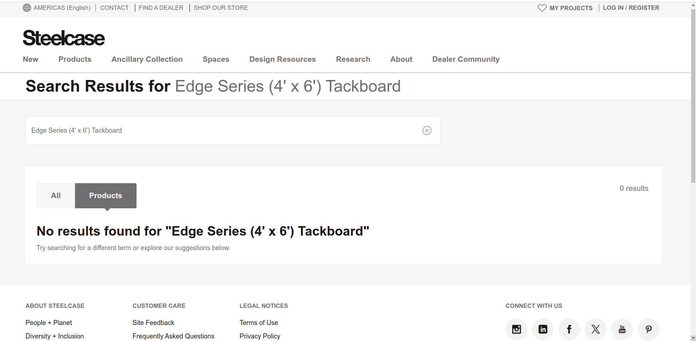

* **Using the mfr number as the search term**

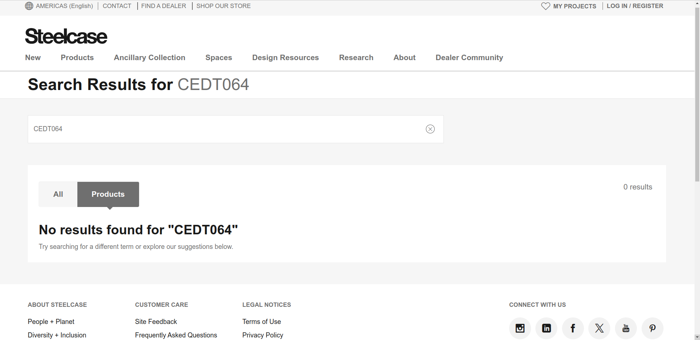

**Note : Sometimes, there are products available for the mfr number but none for the model number. In such cases, we use the mfr number as the search term to find the product.**

**Similar result products:**

* **Model name | mfr number**
* **Turnstone Campfire Big Table 96W x 48D in. | TS4TL28**
* **U-Base | HTU1834RR**
* **Akira Standard Height Flip Top, L-Base (72''x24'') | AKF7224RLC**
* **Universal 30'' Diameter Table with Column Base | BFR30/TS4TBASE285**

**Response:**

**Informations found on the page:**

* **model name**
* **product description**
* **mfr number**
* **dimensions(width, height, depth)**
* **Product weight**
* **certifications**
* **product image**
* **Manual/IFU (pdf)**
* **Brochure (pdf)**
* **Specification Sheet (pdf)**

**Missing : 67**

**Found : 166**

**Response:**